|  |
| --- |
| Close-up image showing the leaf-sides of two oversized books side-by-side on a bookshelf, with additional books in soft focus background |
| Azure Active Directory  Implementing F5 BIG-IP Access Policy Manager (APM) as the PeopleSoft Single Sign-on Solution |
| |  |  |  | | --- | --- | --- | |  |  |  | |

|  |
| --- |
| Implementing F5 BIG-IP Access Policy Manager (APM) as the PeopleSoft Single Sign-on Solution |
| |  |  |  | | --- | --- | --- | |  |  |  | |

|  |
| --- |
| Implementing F5 BIG-IP Access Policy Manager (APM) as the PeopleSoft Single Sign-on Solution |
| |  |  |  | | --- | --- | --- | |  |  |  | |

|  |
| --- |
| Implementing F5 BIG-IP Access Policy Manager (APM) as the PeopleSoft Single Sign-on Solution |
| |  |  |  | | --- | --- | --- | |  |  |  | |

|  |
| --- |
| Implementing F5 BIG-IP Access Policy Manager (APM) as the PeopleSoft Single Sign-on Solution |
| |  |  |  | | --- | --- | --- | |  |  |  | |

|  |
| --- |
| Implementing F5 BIG-IP Access Policy Manager (APM) as the PeopleSoft Single Sign-on Solution |
| |  |  |  | | --- | --- | --- | |  |  |  | |

|  |
| --- |
| Implementing F5 BIG-IP Access Policy Manager (APM) as the PeopleSoft Single Sign-on Solution |
| |  |  |  | | --- | --- | --- | |  |  |  | |

|  |
| --- |
| Implementing F5 BIG-IP Access Policy Manager (APM) as the PeopleSoft Single Sign-on Solution |
| |  |  |  | | --- | --- | --- | |  |  |  | |

|  |
| --- |
| Implementing F5 BIG-IP Access Policy Manager (APM) as the PeopleSoft Single Sign-on Solution |
| |  |  |  | | --- | --- | --- | |  |  |  | |

|  |
| --- |
| Implementing F5 BIG-IP Access Policy Manager (APM) as the PeopleSoft Single Sign-on Solution |
| |  |  |  | | --- | --- | --- | |  |  |  | |

|  |
| --- |
| Implementing F5 BIG-IP Access Policy Manager (APM) as the PeopleSoft Single Sign-on Solution |
| |  |  |  | | --- | --- | --- | |  |  |  | |

|  |
| --- |
| Implementing F5 BIG-IP Access Policy Manager (APM) as the PeopleSoft Single Sign-on Solution |
| |  |  |  | | --- | --- | --- | |  |  |  | |

|  |
| --- |
| Implementing F5 BIG-IP Access Policy Manager (APM) as the PeopleSoft Single Sign-on Solution |
| |  |  |  | | --- | --- | --- | |  |  |  | |

|  |
| --- |
| Implementing F5 BIG-IP Access Policy Manager (APM) as the PeopleSoft Single Sign-on Solution |
| |  |  |  | | --- | --- | --- | |  |  |  | |

|  |
| --- |
| Implementing F5 BIG-IP Access Policy Manager (APM) as the PeopleSoft Single Sign-on Solution |
| |  |  |  | | --- | --- | --- | |  |  |  | |

|  |
| --- |
| Implementing F5 BIG-IP Access Policy Manager (APM) as the PeopleSoft Single Sign-on Solution |
| |  |  |  | | --- | --- | --- | |  |  |  | |

|  |
| --- |
| Implementing F5 BIG-IP Access Policy Manager (APM) as the PeopleSoft Single Sign-on Solution |
| |  |  |  | | --- | --- | --- | |  |  |  | |

|  |
| --- |
| Implementing F5 BIG-IP Access Policy Manager (APM) as the PeopleSoft Single Sign-on Solution |
| |  |  |  | | --- | --- | --- | |  |  |  | |

|  |
| --- |
| Implementing F5 BIG-IP Access Policy Manager (APM) as the PeopleSoft Single Sign-on Solution |
| |  |  |  | | --- | --- | --- | |  |  |  | |

|  |
| --- |
| Implementing F5 BIG-IP Access Policy Manager (APM) as the PeopleSoft Single Sign-on Solution |
| |  |  |  | | --- | --- | --- | |  |  |  | |

|  |
| --- |
| Implementing F5 BIG-IP Access Policy Manager (APM) as the PeopleSoft Single Sign-on Solution |
| |  |  |  | | --- | --- | --- | |  |  |  | |

|  |
| --- |
| Implementing F5 BIG-IP Access Policy Manager (APM) as the PeopleSoft Single Sign-on Solution |
| |  |  |  | | --- | --- | --- | |  |  |  | |

|  |
| --- |
| Implementing F5 BIG-IP Access Policy Manager (APM) as the PeopleSoft Single Sign-on Solution |
| |  |  |  | | --- | --- | --- | |  |  |  | |

|  |
| --- |
| Implementing F5 BIG-IP Access Policy Manager (APM) as the PeopleSoft Single Sign-on Solution |
| |  |  |  | | --- | --- | --- | |  |  |  | |

|  |
| --- |
| Implementing F5 BIG-IP Access Policy Manager (APM) as the PeopleSoft Single Sign-on Solution |
| |  |  |  | | --- | --- | --- | |  |  |  | |

|  |
| --- |
| Implementing F5 BIG-IP Access Policy Manager (APM) as the PeopleSoft Single Sign-on Solution |
| |  |  |  | | --- | --- | --- | |  |  |  | |

|  |
| --- |
| Implementing F5 BIG-IP Access Policy Manager (APM) as the PeopleSoft Single Sign-on Solution |
| |  |  |  | | --- | --- | --- | |  |  |  | |

|  |
| --- |
| Implementing F5 BIG-IP Access Policy Manager (APM) as the PeopleSoft Single Sign-on Solution |
| |  |  |  | | --- | --- | --- | |  |  |  | |

|  |
| --- |
| Implementing F5 BIG-IP Access Policy Manager (APM) as the PeopleSoft Single Sign-on Solution |
| |  |  |  | | --- | --- | --- | |  |  |  | |

|  |
| --- |
| Implementing F5 BIG-IP Access Policy Manager (APM) as the PeopleSoft Single Sign-on Solution |
| |  |  |  | | --- | --- | --- | |  |  |  | |

|  |
| --- |
| Implementing F5 BIG-IP Access Policy Manager (APM) as the PeopleSoft Single Sign-on Solution |
| |  |  |  | | --- | --- | --- | |  |  |  | |

|  |
| --- |
| Implementing F5 BIG-IP Access Policy Manager (APM) as the PeopleSoft Single Sign-on Solution |
| |  |  |  | | --- | --- | --- | |  |  |  | |

|  |
| --- |
| Implementing F5 BIG-IP Access Policy Manager (APM) as the PeopleSoft Single Sign-on Solution |
| |  |  |  | | --- | --- | --- | |  |  |  | |

|  |
| --- |
| Implementing F5 BIG-IP Access Policy Manager (APM) as the PeopleSoft Single Sign-on Solution |
| |  |  |  | | --- | --- | --- | |  |  |  | |

|  |
| --- |
| Implementing F5 BIG-IP Access Policy Manager (APM) as the PeopleSoft Single Sign-on Solution |
| |  |  |  | | --- | --- | --- | |  |  |  | |

|  |
| --- |
| Implementing F5 BIG-IP Access Policy Manager (APM) as the PeopleSoft Single Sign-on Solution |
| |  |  |  | | --- | --- | --- | |  |  |  | |

|  |
| --- |
| Implementing F5 BIG-IP Access Policy Manager (APM) as the PeopleSoft Single Sign-on Solution |
| |  |  |  | | --- | --- | --- | |  |  |  | |

|  |
| --- |
| Implementing F5 BIG-IP Access Policy Manager (APM) as the PeopleSoft Single Sign-on Solution |
| |  |  |  | | --- | --- | --- | |  |  |  | |

|  |
| --- |
| Implementing F5 BIG-IP Access Policy Manager (APM) as the PeopleSoft Single Sign-on Solution |
| |  |  |  | | --- | --- | --- | |  |  |  | |

|  |
| --- |
| Implementing F5 BIG-IP Access Policy Manager (APM) as the PeopleSoft Single Sign-on Solution |
| |  |  |  | | --- | --- | --- | |  |  |  | |

|  |
| --- |
| Implementing F5 BIG-IP Access Policy Manager (APM) as the PeopleSoft Single Sign-on Solution |
| |  |  |  | | --- | --- | --- | |  |  |  | |

|  |
| --- |
| Implementing F5 BIG-IP Access Policy Manager (APM) as the PeopleSoft Single Sign-on Solution |
| |  |  |  | | --- | --- | --- | |  |  |  | |

|  |
| --- |
| Implementing F5 BIG-IP Access Policy Manager (APM) as the PeopleSoft Single Sign-on Solution |
| |  |  |  | | --- | --- | --- | |  |  |  | |

|  |
| --- |
| Implementing F5 BIG-IP Access Policy Manager (APM) as the PeopleSoft Single Sign-on Solution |
| |  |  |  | | --- | --- | --- | |  |  |  | |

|  |
| --- |
| Implementing F5 BIG-IP Access Policy Manager (APM) as the PeopleSoft Single Sign-on Solution |
| |  |  |  | | --- | --- | --- | |  |  |  | |

|  |
| --- |
| Implementing F5 BIG-IP Access Policy Manager (APM) as the PeopleSoft Single Sign-on Solution |
| |  |  |  | | --- | --- | --- | |  |  |  | |

|  |
| --- |
| Implementing F5 BIG-IP Access Policy Manager (APM) as the PeopleSoft Single Sign-on Solution |
| |  |  |  | | --- | --- | --- | |  |  |  | |

|  |
| --- |
| Implementing F5 BIG-IP Access Policy Manager (APM) as the PeopleSoft Single Sign-on Solution |
| |  |  |  | | --- | --- | --- | |  |  |  | |

|  |
| --- |
| Implementing F5 BIG-IP Access Policy Manager (APM) as the PeopleSoft Single Sign-on Solution |
| |  |  |  | | --- | --- | --- | |  |  |  | |

|  |
| --- |
| Implementing F5 BIG-IP Access Policy Manager (APM) as the PeopleSoft Single Sign-on Solution |
| |  |  |  | | --- | --- | --- | |  |  |  | |

|  |
| --- |
| Implementing F5 BIG-IP Access Policy Manager (APM) as the PeopleSoft Single Sign-on Solution |
| |  |  |  | | --- | --- | --- | |  |  |  | |

|  |
| --- |
| Implementing F5 BIG-IP Access Policy Manager (APM) as the PeopleSoft Single Sign-on Solution |
| |  |  |  | | --- | --- | --- | |  |  |  | |

|  |
| --- |
| Implementing F5 BIG-IP Access Policy Manager (APM) as the PeopleSoft Single Sign-on Solution |
| |  |  |  | | --- | --- | --- | |  |  |  | |

|  |
| --- |
| Implementing F5 BIG-IP Access Policy Manager (APM) as the PeopleSoft Single Sign-on Solution |
| |  |  |  | | --- | --- | --- | |  |  |  | |

|  |
| --- |
| Implementing F5 BIG-IP Access Policy Manager (APM) as the PeopleSoft Single Sign-on Solution |
| |  |  |  | | --- | --- | --- | |  |  |  | |

|  |
| --- |
| Implementing F5 BIG-IP Access Policy Manager (APM) as the PeopleSoft Single Sign-on Solution |
| |  |  |  | | --- | --- | --- | |  |  |  | |

|  |
| --- |
| Implementing F5 BIG-IP Access Policy Manager (APM) as the PeopleSoft Single Sign-on Solution |
| |  |  |  | | --- | --- | --- | |  |  |  | |

|  |
| --- |
| Implementing F5 BIG-IP Access Policy Manager (APM) as the PeopleSoft Single Sign-on Solution |
| |  |  |  | | --- | --- | --- | |  |  |  | |

|  |
| --- |
| Implementing F5 BIG-IP Access Policy Manager (APM) as the PeopleSoft Single Sign-on Solution |
| |  |  |  | | --- | --- | --- | |  |  |  | |

|  |
| --- |
| Implementing F5 BIG-IP Access Policy Manager (APM) as the PeopleSoft Single Sign-on Solution |
| |  |  |  | | --- | --- | --- | |  |  |  | |

|  |
| --- |
| Implementing F5 BIG-IP Access Policy Manager (APM) as the PeopleSoft Single Sign-on Solution |
| |  |  |  | | --- | --- | --- | |  |  |  | |

|  |
| --- |
| Implementing F5 BIG-IP Access Policy Manager (APM) as the PeopleSoft Single Sign-on Solution |
| |  |  |  | | --- | --- | --- | |  |  |  | |

|  |
| --- |
| Implementing F5 BIG-IP Access Policy Manager (APM) as the PeopleSoft Single Sign-on Solution |
| |  |  |  | | --- | --- | --- | |  |  |  | |

|  |
| --- |
| Implementing F5 BIG-IP Access Policy Manager (APM) as the PeopleSoft Single Sign-on Solution |
| |  |  |  | | --- | --- | --- | |  |  |  | |

|  |
| --- |
| Implementing F5 BIG-IP Access Policy Manager (APM) as the PeopleSoft Single Sign-on Solution |
| |  |  |  | | --- | --- | --- | |  |  |  | |

|  |
| --- |
| Implementing F5 BIG-IP Access Policy Manager (APM) as the PeopleSoft Single Sign-on Solution |
| |  |  |  | | --- | --- | --- | |  |  |  | |

|  |
| --- |
| Implementing F5 BIG-IP Access Policy Manager (APM) as the PeopleSoft Single Sign-on Solution |
| |  |  |  | | --- | --- | --- | |  |  |  | |

|  |
| --- |
| Implementing F5 BIG-IP Access Policy Manager (APM) as the PeopleSoft Single Sign-on Solution |
| |  |  |  | | --- | --- | --- | |  |  |  | |

|  |
| --- |
| Implementing F5 BIG-IP Access Policy Manager (APM) as the PeopleSoft Single Sign-on Solution |
| |  |  |  | | --- | --- | --- | |  |  |  | |

|  |
| --- |
| Implementing F5 BIG-IP Access Policy Manager (APM) as the PeopleSoft Single Sign-on Solution |
| |  |  |  | | --- | --- | --- | |  |  |  | |

|  |
| --- |
| Implementing F5 BIG-IP Access Policy Manager (APM) as the PeopleSoft Single Sign-on Solution |
| |  |  |  | | --- | --- | --- | |  |  |  | |

|  |
| --- |
| Implementing F5 BIG-IP Access Policy Manager (APM) as the PeopleSoft Single Sign-on Solution |
| |  |  |  | | --- | --- | --- | |  |  |  | |

|  |
| --- |
| Implementing F5 BIG-IP Access Policy Manager (APM) as the PeopleSoft Single Sign-on Solution |
| |  |  |  | | --- | --- | --- | |  |  |  | |

|  |
| --- |
| Implementing F5 BIG-IP Access Policy Manager (APM) as the PeopleSoft Single Sign-on Solution |
| |  |  |  | | --- | --- | --- | |  |  |  | |

|  |
| --- |
| Implementing F5 BIG-IP Access Policy Manager (APM) as the PeopleSoft Single Sign-on Solution |
| |  |  |  | | --- | --- | --- | |  |  |  | |

|  |
| --- |
| Implementing F5 BIG-IP Access Policy Manager (APM) as the PeopleSoft Single Sign-on Solution |
| |  |  |  | | --- | --- | --- | |  |  |  | |

|  |
| --- |
| Implementing F5 BIG-IP Access Policy Manager (APM) as the PeopleSoft Single Sign-on Solution |
| |  |  |  | | --- | --- | --- | |  |  |  | |

|  |
| --- |
| Implementing F5 BIG-IP Access Policy Manager (APM) as the PeopleSoft Single Sign-on Solution |
| |  |  |  | | --- | --- | --- | |  |  |  | |

|  |
| --- |
| Implementing F5 BIG-IP Access Policy Manager (APM) as the PeopleSoft Single Sign-on Solution |
| |  |  |  | | --- | --- | --- | |  |  |  | |

|  |
| --- |
| Implementing F5 BIG-IP Access Policy Manager (APM) as the PeopleSoft Single Sign-on Solution |
| |  |  |  | | --- | --- | --- | |  |  |  | |

|  |
| --- |
| Implementing F5 BIG-IP Access Policy Manager (APM) as the PeopleSoft Single Sign-on Solution |
| |  |  |  | | --- | --- | --- | |  |  |  | |

|  |
| --- |
| Implementing F5 BIG-IP Access Policy Manager (APM) as the PeopleSoft Single Sign-on Solution |
| |  |  |  | | --- | --- | --- | |  |  |  | |

|  |
| --- |
| Implementing F5 BIG-IP Access Policy Manager (APM) as the PeopleSoft Single Sign-on Solution |
| |  |  |  | | --- | --- | --- | |  |  |  | |

|  |
| --- |
| Implementing F5 BIG-IP Access Policy Manager (APM) as the PeopleSoft Single Sign-on Solution |
| |  |  |  | | --- | --- | --- | |  |  |  | |

|  |
| --- |
| Implementing F5 BIG-IP Access Policy Manager (APM) as the PeopleSoft Single Sign-on Solution |
| |  |  |  | | --- | --- | --- | |  |  |  | |

|  |
| --- |
| Implementing F5 BIG-IP Access Policy Manager (APM) as the PeopleSoft Single Sign-on Solution |
| |  |  |  | | --- | --- | --- | |  |  |  | |

|  |
| --- |
| Implementing F5 BIG-IP Access Policy Manager (APM) as the PeopleSoft Single Sign-on Solution |
| |  |  |  | | --- | --- | --- | |  |  |  | |

|  |
| --- |
| Implementing F5 BIG-IP Access Policy Manager (APM) as the PeopleSoft Single Sign-on Solution |
| |  |  |  | | --- | --- | --- | |  |  |  | |

|  |
| --- |
| Implementing F5 BIG-IP Access Policy Manager (APM) as the PeopleSoft Single Sign-on Solution |
| |  |  |  | | --- | --- | --- | |  |  |  | |

|  |
| --- |
| Implementing F5 BIG-IP Access Policy Manager (APM) as the PeopleSoft Single Sign-on Solution |
| |  |  |  | | --- | --- | --- | |  |  |  | |

|  |
| --- |
| Implementing F5 BIG-IP Access Policy Manager (APM) as the PeopleSoft Single Sign-on Solution |
| |  |  |  | | --- | --- | --- | |  |  |  | |

|  |
| --- |
| Implementing F5 BIG-IP Access Policy Manager (APM) as the PeopleSoft Single Sign-on Solution |
| |  |  |  | | --- | --- | --- | |  |  |  | |

|  |
| --- |
| Implementing F5 BIG-IP Access Policy Manager (APM) as the PeopleSoft Single Sign-on Solution |
| |  |  |  | | --- | --- | --- | |  |  |  | |

|  |
| --- |
| Implementing F5 BIG-IP Access Policy Manager (APM) as the PeopleSoft Single Sign-on Solution |
| |  |  |  | | --- | --- | --- | |  |  |  | |

|  |
| --- |
| Implementing F5 BIG-IP Access Policy Manager (APM) as the PeopleSoft Single Sign-on Solution |
| |  |  |  | | --- | --- | --- | |  |  |  | |

|  |
| --- |
| Implementing F5 BIG-IP Access Policy Manager (APM) as the PeopleSoft Single Sign-on Solution |
| |  |  |  | | --- | --- | --- | |  |  |  | |

|  |
| --- |
| Implementing F5 BIG-IP Access Policy Manager (APM) as the PeopleSoft Single Sign-on Solution |
| |  |  |  | | --- | --- | --- | |  |  |  | |

|  |
| --- |
| Implementing F5 BIG-IP Access Policy Manager (APM) as the PeopleSoft Single Sign-on Solution |
| |  |  |  | | --- | --- | --- | |  |  |  | |

|  |
| --- |
| Implementing F5 BIG-IP Access Policy Manager (APM) as the PeopleSoft Single Sign-on Solution |
| |  |  |  | | --- | --- | --- | |  |  |  | |

|  |
| --- |
| Implementing F5 BIG-IP Access Policy Manager (APM) as the PeopleSoft Single Sign-on Solution |
| |  |  |  | | --- | --- | --- | |  |  |  | |

|  |
| --- |
| Implementing F5 BIG-IP Access Policy Manager (APM) as the PeopleSoft Single Sign-on Solution |
| |  |  |  | | --- | --- | --- | |  |  |  | |

|  |
| --- |
| Implementing F5 BIG-IP Access Policy Manager (APM) as the PeopleSoft Single Sign-on Solution |
| |  |  |  | | --- | --- | --- | |  |  |  | |

|  |
| --- |
| Implementing F5 BIG-IP Access Policy Manager (APM) as the PeopleSoft Single Sign-on Solution |
| |  |  |  | | --- | --- | --- | |  |  |  | |

|  |
| --- |
| Implementing F5 BIG-IP Access Policy Manager (APM) as the PeopleSoft Single Sign-on Solution |
| |  |  |  | | --- | --- | --- | |  |  |  | |

|  |
| --- |
| Implementing F5 BIG-IP Access Policy Manager (APM) as the PeopleSoft Single Sign-on Solution |
| |  |  |  | | --- | --- | --- | |  |  |  | |

|  |
| --- |
| Implementing F5 BIG-IP Access Policy Manager (APM) as the PeopleSoft Single Sign-on Solution |
| |  |  |  | | --- | --- | --- | |  |  |  | |

|  |
| --- |
| Implementing F5 BIG-IP Access Policy Manager (APM) as the PeopleSoft Single Sign-on Solution |
| |  |  |  | | --- | --- | --- | |  |  |  | |

|  |
| --- |
| Implementing F5 BIG-IP Access Policy Manager (APM) as the PeopleSoft Single Sign-on Solution |
| |  |  |  | | --- | --- | --- | |  |  |  | |

|  |
| --- |
| Implementing F5 BIG-IP Access Policy Manager (APM) as the PeopleSoft Single Sign-on Solution |
| |  |  |  | | --- | --- | --- | |  |  |  | |

|  |
| --- |
| Implementing F5 BIG-IP Access Policy Manager (APM) as the PeopleSoft Single Sign-on Solution |
| |  |  |  | | --- | --- | --- | |  |  |  | |

|  |
| --- |
| Implementing F5 BIG-IP Access Policy Manager (APM) as the PeopleSoft Single Sign-on Solution |
| |  |  |  | | --- | --- | --- | |  |  |  | |

|  |
| --- |
| Implementing F5 BIG-IP Access Policy Manager (APM) as the PeopleSoft Single Sign-on Solution |
| |  |  |  | | --- | --- | --- | |  |  |  | |

|  |
| --- |
| Implementing F5 BIG-IP Access Policy Manager (APM) as the PeopleSoft Single Sign-on Solution |
| |  |  |  | | --- | --- | --- | |  |  |  | |

|  |
| --- |
| Implementing F5 BIG-IP Access Policy Manager (APM) as the PeopleSoft Single Sign-on Solution |
| |  |  |  | | --- | --- | --- | |  |  |  | |

|  |
| --- |
| Implementing F5 BIG-IP Access Policy Manager (APM) as the PeopleSoft Single Sign-on Solution |
| |  |  |  | | --- | --- | --- | |  |  |  | |

|  |
| --- |
| Implementing F5 BIG-IP Access Policy Manager (APM) as the PeopleSoft Single Sign-on Solution |
| |  |  |  | | --- | --- | --- | |  |  |  | |

|  |
| --- |
| Implementing F5 BIG-IP Access Policy Manager (APM) as the PeopleSoft Single Sign-on Solution |
| |  |  |  | | --- | --- | --- | |  |  |  | |

|  |
| --- |
| Implementing F5 BIG-IP Access Policy Manager (APM) as the PeopleSoft Single Sign-on Solution |
| |  |  |  | | --- | --- | --- | |  |  |  | |

|  |
| --- |
| Implementing F5 BIG-IP Access Policy Manager (APM) as the PeopleSoft Single Sign-on Solution |
| |  |  |  | | --- | --- | --- | |  |  |  | |

|  |
| --- |
| Implementing F5 BIG-IP Access Policy Manager (APM) as the PeopleSoft Single Sign-on Solution |
| |  |  |  | | --- | --- | --- | |  |  |  | |

|  |
| --- |
| Implementing F5 BIG-IP Access Policy Manager (APM) as the PeopleSoft Single Sign-on Solution |
| |  |  |  | | --- | --- | --- | |  |  |  | |

|  |
| --- |
| Implementing F5 BIG-IP Access Policy Manager (APM) as the PeopleSoft Single Sign-on Solution |
| |  |  |  | | --- | --- | --- | |  |  |  | |

|  |
| --- |
| Implementing F5 BIG-IP Access Policy Manager (APM) as the PeopleSoft Single Sign-on Solution |
| |  |  |  | | --- | --- | --- | |  |  |  | |

|  |
| --- |
| Implementing F5 BIG-IP Access Policy Manager (APM) as the PeopleSoft Single Sign-on Solution |
| |  |  |  | | --- | --- | --- | |  |  |  | |

|  |
| --- |
| Implementing F5 BIG-IP Access Policy Manager (APM) as the PeopleSoft Single Sign-on Solution |
| |  |  |  | | --- | --- | --- | |  |  |  | |

|  |
| --- |
| Implementing F5 BIG-IP Access Policy Manager (APM) as the PeopleSoft Single Sign-on Solution |
| |  |  |  | | --- | --- | --- | |  |  |  | |

|  |
| --- |
| Implementing F5 BIG-IP Access Policy Manager (APM) as the PeopleSoft Single Sign-on Solution |
| |  |  |  | | --- | --- | --- | |  |  |  | |

|  |
| --- |
| Implementing F5 BIG-IP Access Policy Manager (APM) as the PeopleSoft Single Sign-on Solution |
| |  |  |  | | --- | --- | --- | |  |  |  | |

Contents

Introduction 2

Prerequisites 2

Part 1: Setting up Azure Active Directory Integration 3

Part 2: F5 SAML SP Configuration 7

Part 3: Configuring APM Access Profile 11

Part 4: Configuring Application 12

Part 5. Setting up PeopleSoft application to support F5 Big-IP APM as the single sign-on solution 15

Part 6. Setting up F5 Big-IP APM to populate “PS_SSO_UID” HTTP Header with the PeopleSoft User ID 17

Appendix 19

# Introduction

This guide covers Integration of Azure Active Directory and Oracle PeopleSoft On-Premise applications with F5 BIG-IP APM (Access Policy Manager). The document describes ability to secure publish the PeopleSoft application using F5 and be able to securely Integrate with Azure AD Platform leveraging some of the core functionalities like Azure AD Conditional Access and Identity Protection Services.

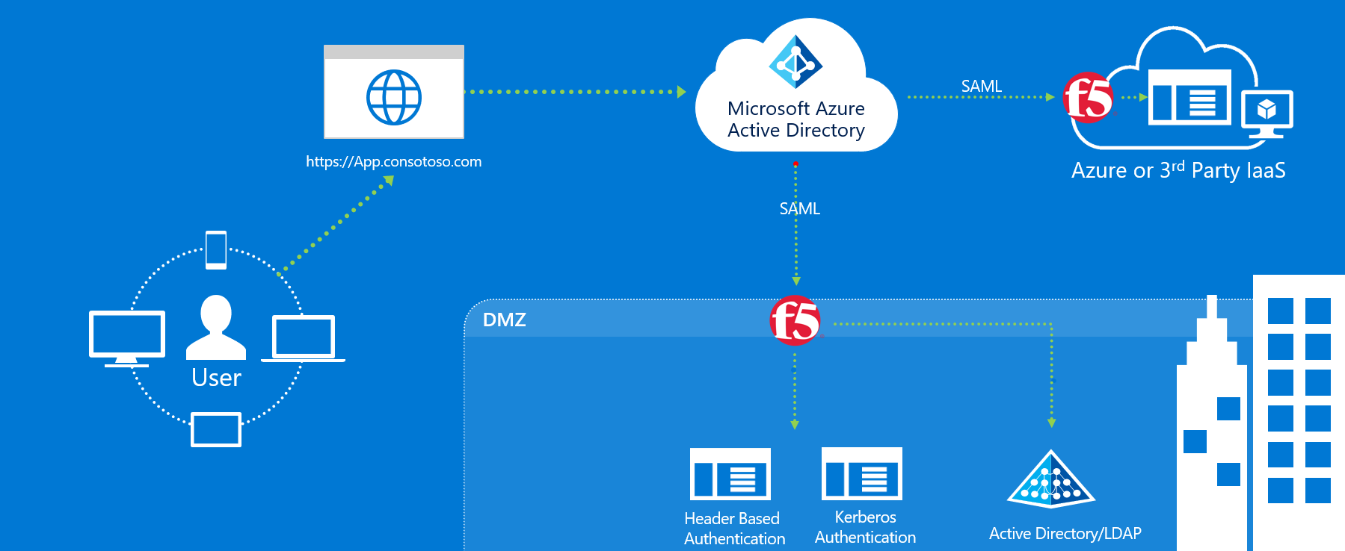

The Above Integration allows enterprises to leverage F5 with Azure AD to cover the both Modern authentication and header Authentication using Azure Active Directory as control Plane.

|  |  |  |
| --- | --- | --- |
| **PeopleSoft** | **Azure AD** | **F5 BIG-IP** |
| Header Based Authentication | SAML IDP - Azure Conditional Access / Identity Protection Services | SAML SP - Maps SAML Assertion to HTTP Headers for PeopleSoft Application consumption |

# Pre-requisites

1. Deploying the joint solution requires the following license:

* F5 BIG-IP® Best bundle (or)
* F5 BIG-IP Access Policy Manager™ (APM) standalone license
* F5 BIG-IP Access Policy Manager™ (APM) add-on license on an existing BIG-IP F5 BIG-IP® Local Traffic Manager™ (LTM).
* In addition to the above license, the F5 system may also be licensed with:
  + A URL Filtering subscription to use the URL category database
  + An F5 IP Intelligence subscription to detect and block known attackers and malicious traffic
  + A network hardware security module (HSM) to safeguard and manage digital keys for strong authentication

1. F5 BIG-IP system is provisioned with APM modules (LTM is optional)
2. Although optional, it is highly recommended to Deploy the F5 systems in a [sync/failover device group](https://techdocs.f5.com/kb/en-us/products/big-ip_ltm/manuals/product/big-ip-device-service-clustering-administration-14-1-0.html) (S/F DG), which includes the active standby pair, with a floating IP address for high availability (HA). Further interface redundancy can be achieved using the Link Aggregation Control Protocol (LACP). LACP manages the connected physical interfaces as a single virtual interface (aggregate group) and detects any interface failures within the group.

## Part 1: Setting up Azure Active Directory Integration

Select Enterprise Application Blade and add the “F5 BIG-IP APM Azure AD integration” from the gallery.

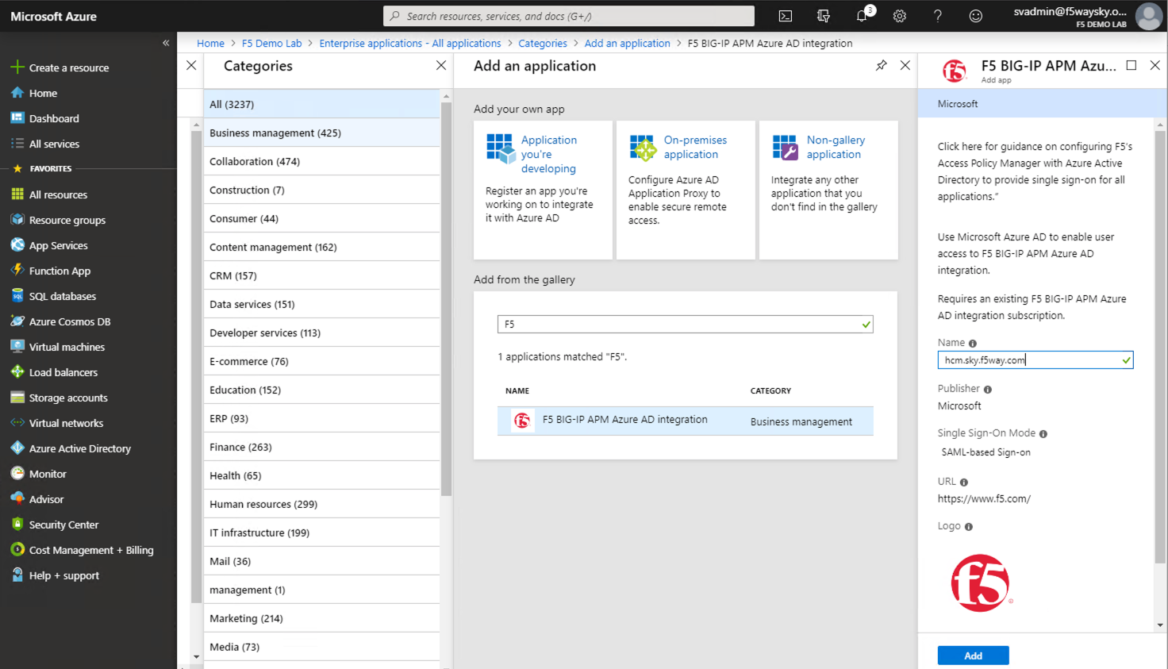

Navigate to the Users and Groups and Specify the users entitled for the PeopleSoft application.

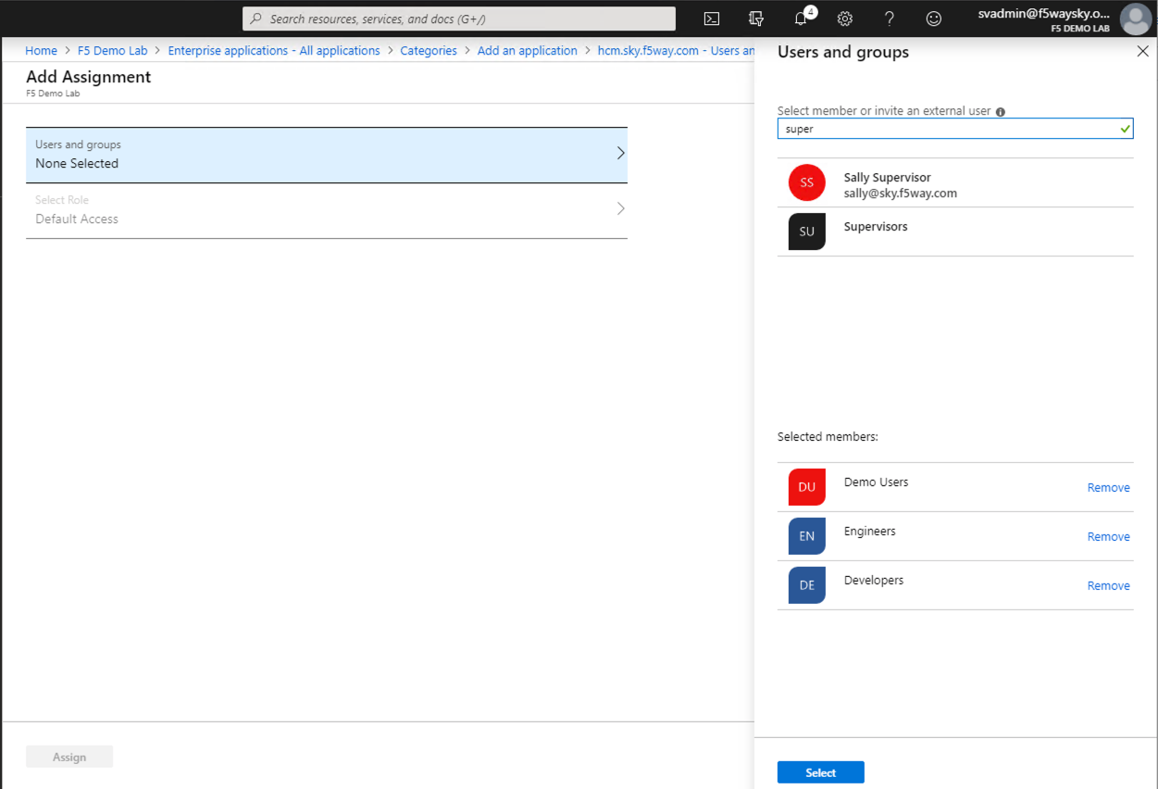

Specify SAML as the Single Sign-on method.

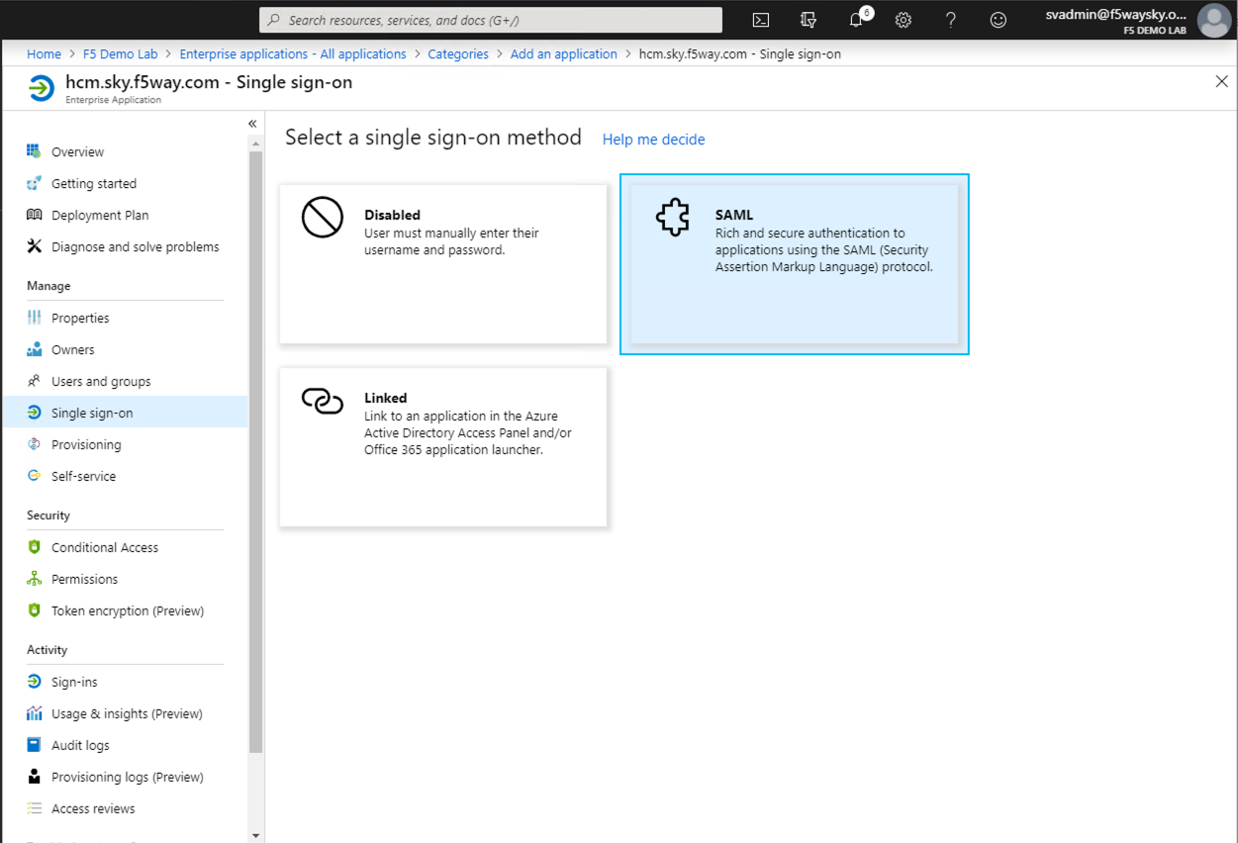

Complete the Basic SAML Configuration Section

Specify the Identifier (Entity ID) and Reply URL, in our example <https://hcm.sky.f5way.com> is Entity ID and <https://hcm.sky.f5way.com/saml/sp/profile/post/acs> is Assertion Consumer Service URL.

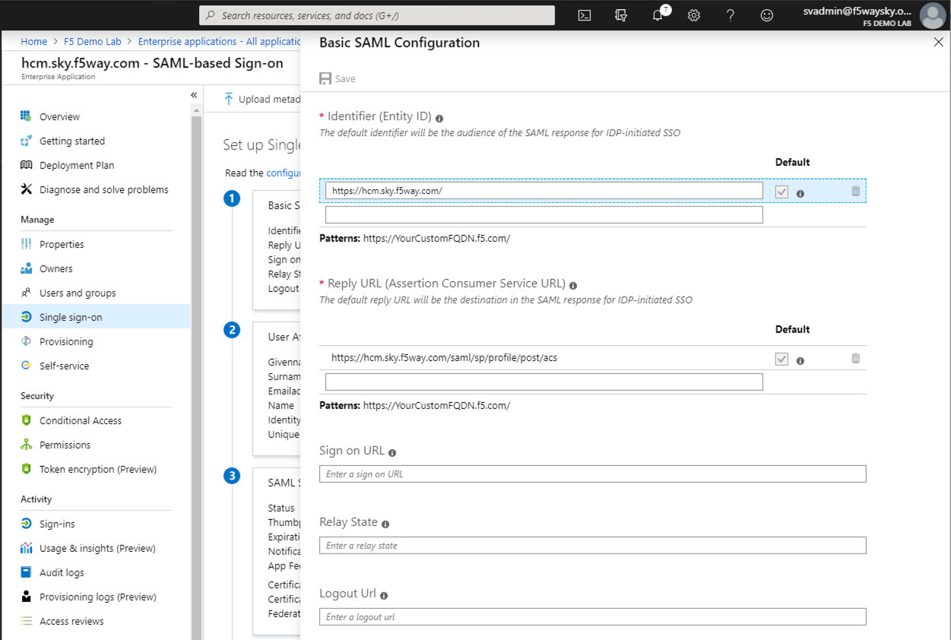

Customize claims issued in the SAML token for PeopleSoft application. Add new SAML attribute which is used as PeopleSoft User ID.

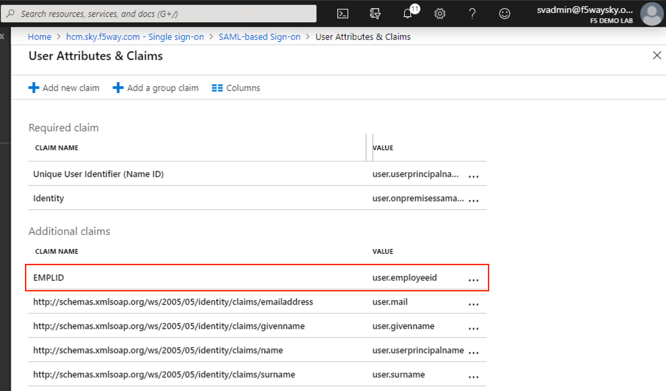

Download the Federation Metadata XML and the Certificate (Base64)

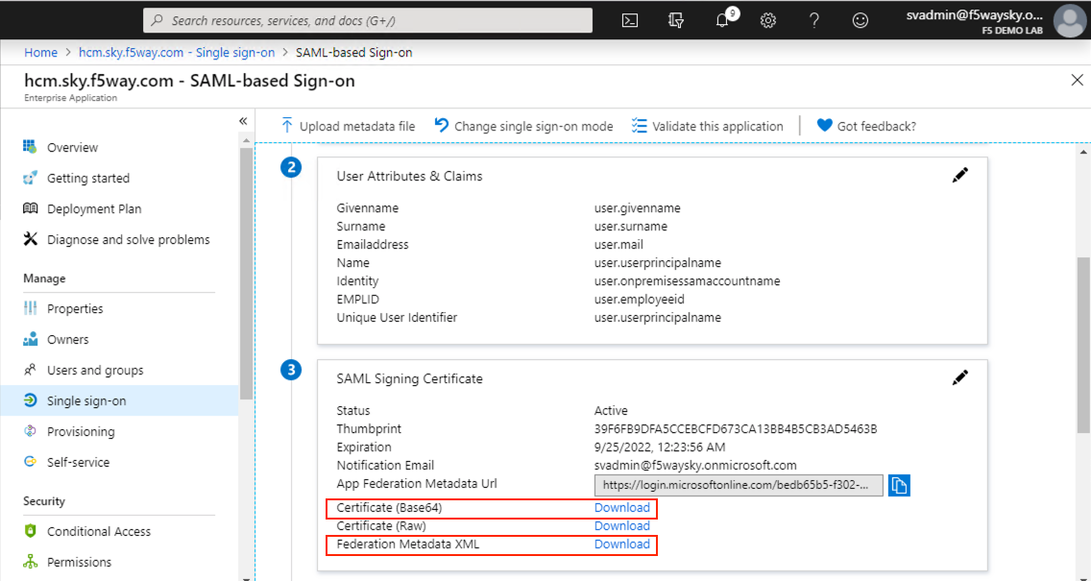

#### Note the following details from the XML file (Optional only for reference)

* entityID
* SingleLogoutService Location
* SingleSignOnService Location

Example:

* [entityID="https://sts.windows.net/bedb65b5-f302-42f8-ac94-08bdc945152a/"](entityID=%22https://sts.windows.net/bedb65b5-f302-42f8-ac94-08bdc945152a/%22)
* SingleLogoutService Location="**https://login.microsoftonline.com/bedb65b5-f302-42f8-ac94-08bdc945152a/saml2**"
* SingleSignOnService Location="[**https://login.microsoftonline.com/bedb65b5-f302-42f8-ac94-08bdc945152a/saml2**](https://login.microsoftonline.com/bedb65b5-f302-42f8-ac94-08bdc945152a/saml2)"

# *Part 2:* F5 SAML SP Configuration

You will need to import the Metadata Certificate into the F5 which will be used later in the setup process. Navigate to System > Certificate Management > Traffic Certificate Management > SSL Certificate List. Select **Import** from the right-hand corner.

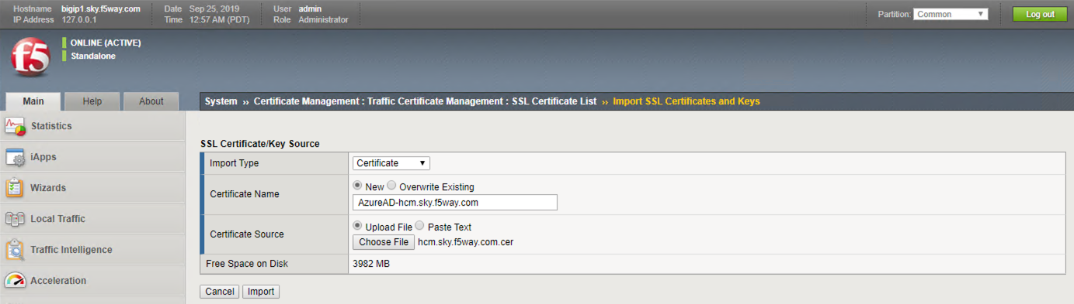

Setup the SAML IDP Connector:

Navigate to Access > Federation > SAML: Service Provider > External Idp Connectors and click Create > From Metadata.

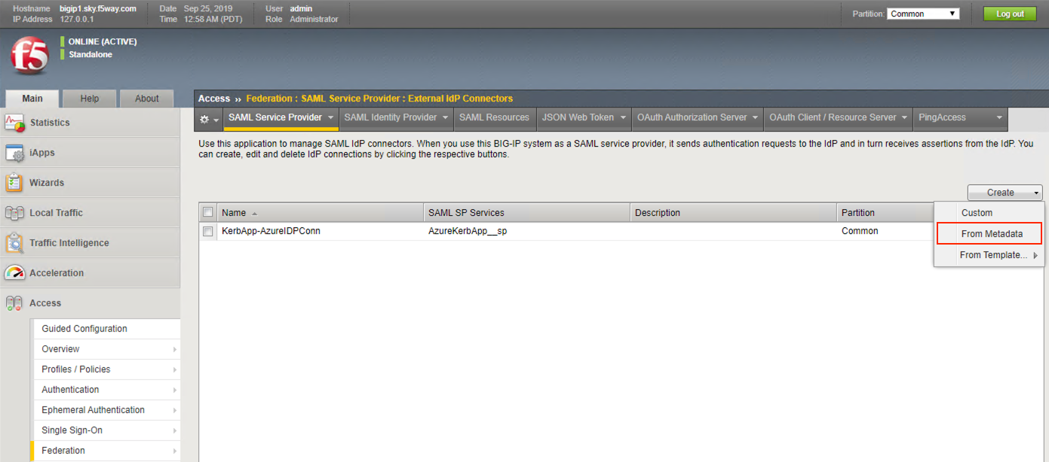

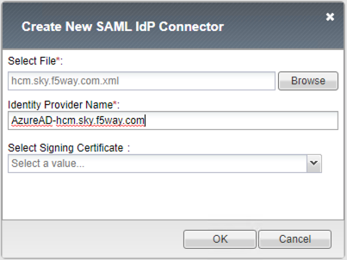

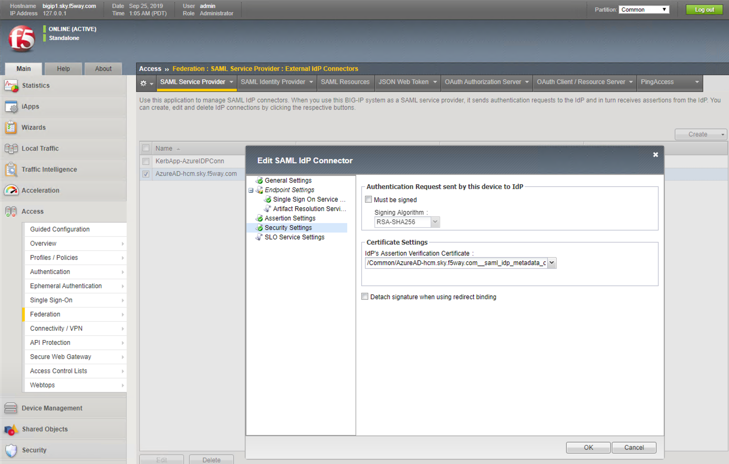

Setup the SAML SP:

Navigate to Access > Federation > SAML Service Provider > Local SP Services and click **Create**. Complete the following information and click **OK**.

* Name: PeopleSoftAppSSO
* Entity ID*: https://hcm.sky.f5way.com
* SP Name Settings
  + Scheme: https
  + Host: hcm.sky.f5way.com
  + Description: SP object for PeopleSoftAppSSO

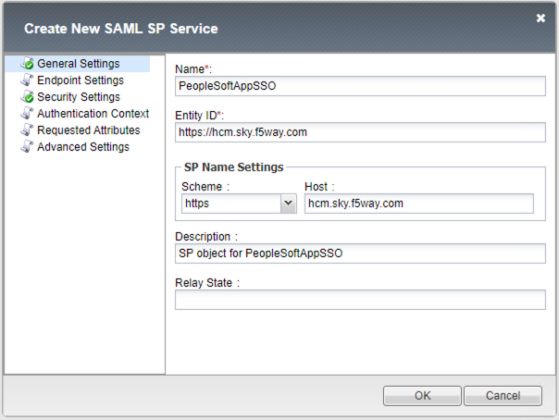

Select the SP Configuration, PeopleSoftAppSSO, and Click **Bind/UnBind IdP Connectors**.

Click on **Add New Row** and Select the **External IdP connector** created in previous step, click **Update**, and then click **OK**.

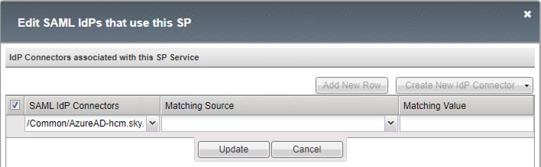

# Part 3: Configuring APM Access Profile

Navigate to Access > Profile/Policies > Access Profile (per session policies), click **Create**, complete the following information and click **Finished**.

* Name: PeopleSoftApp
* Profile Type: All
* Profile Scope: Profile
* Languages: English

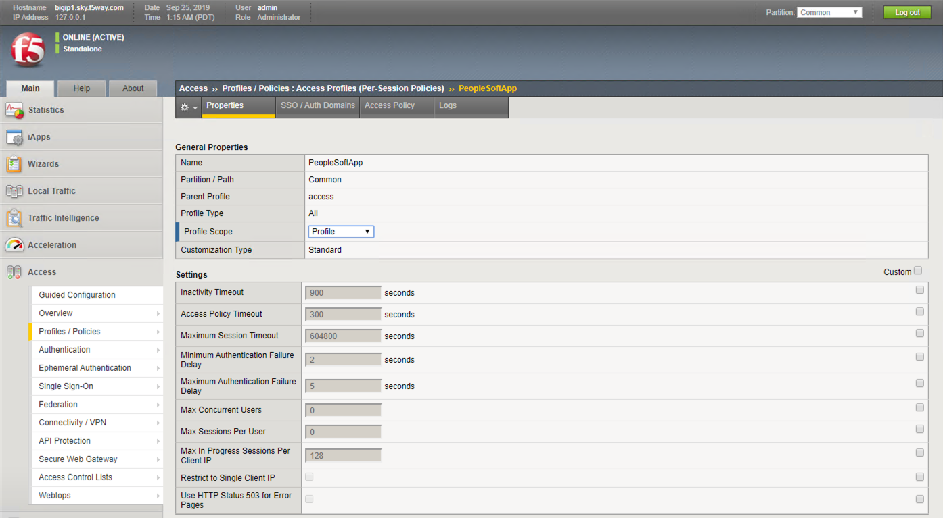

Click **Access Policy** and then click **Edit Access Policy** for Profile “PeopleSoftApp”

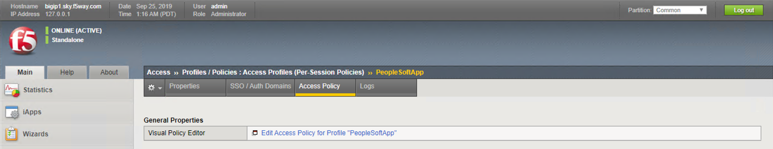

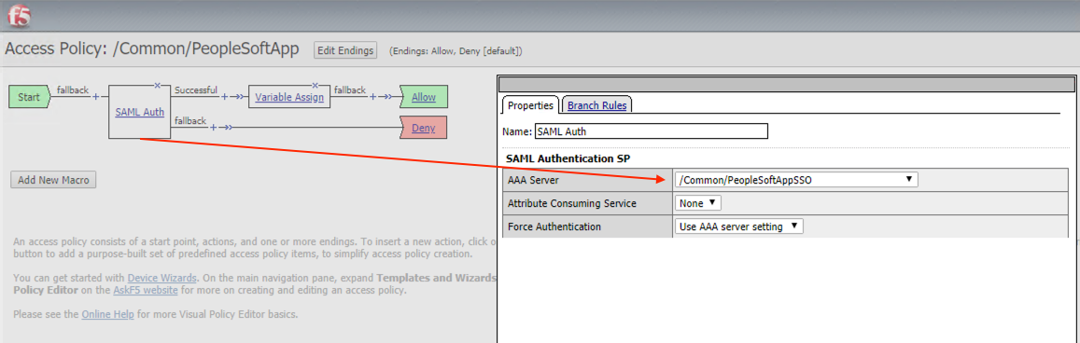

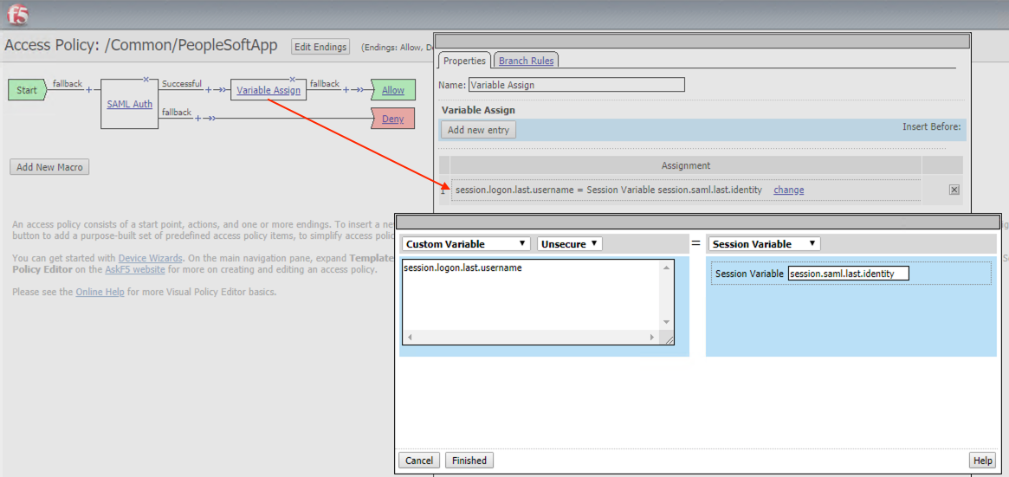

session.logon.last.username = mcget {session.saml.last.identity}

# Part 4: Configuring Application

**Create a new Pool**

Navigate to **Local Traffic > Pools > Pool List**, click **Create**, complete the following information and click **Finished**.

* Name: PeopleSoft-Pool
* Description: PeopleSoft-Pool
* Health Monitors: http
* Address: 10.10.10.10
* Service Port: 8000

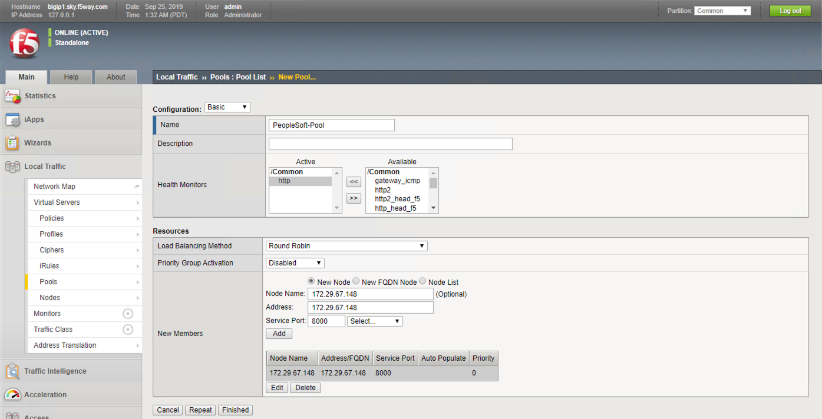

**Create a new Client SSL profile**

Navigate to Loca**l Traffic > Profiles > SSL > Client >** +, complete the following information and click **Finished**.

* Name: PeopleSoftApp-clissl
* Certificate: hcm.sky.f5way.com
* Key: hcm.sky.f5way.com

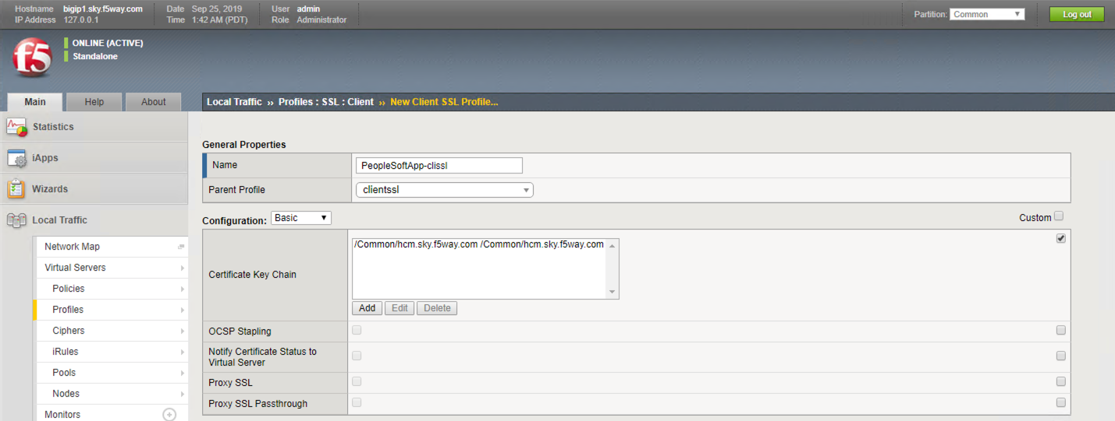

**Create a new Virtual Server**

Navigate to Loca**l Traffic > Virtual Servers > Virtual Server List >** +, complete the following information and click **Finished**.

* Name: PeopleSoftApp
* Destination Address/Mask: Host 10.10.10.32
* Service Port: Port 443 HTTPS
* HTTP Profile (Client): http
* SSL Profile (Client): PeopleSoftApp-clissl
* Source Address Translation: Auto Map
* Access Profile: PeopleSoftApp
* Default Pool: PeopleSoft-Pool

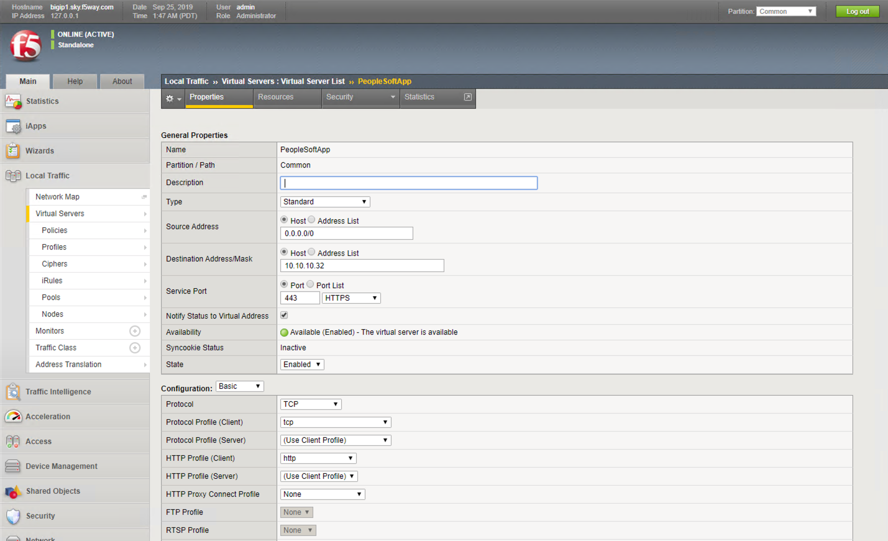

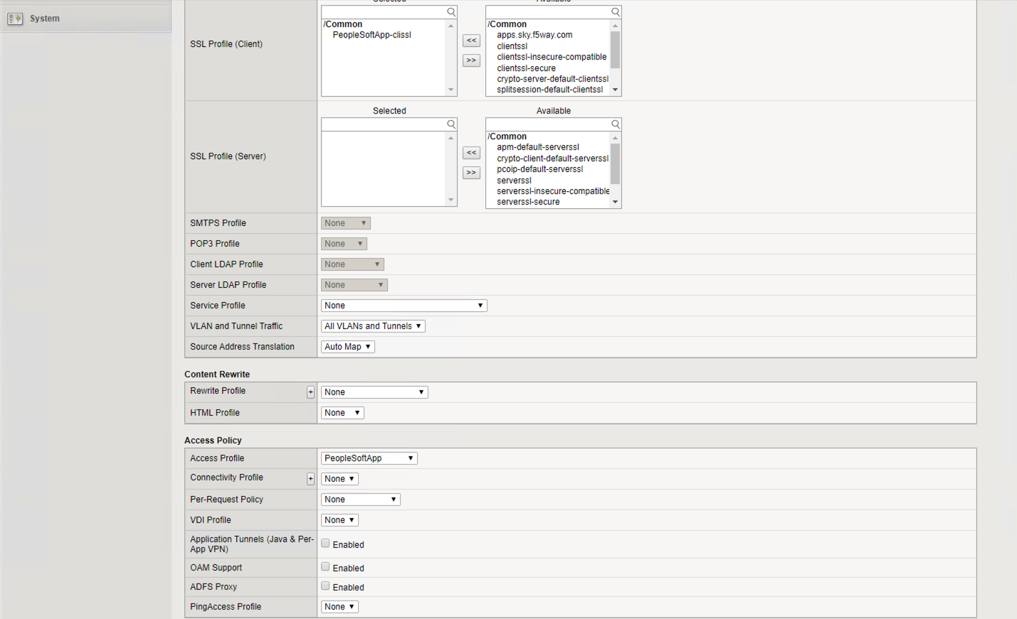

# Part 5. Setting up PeopleSoft application to support F5 Big-IP APM as the single sign-on solution

Note: Reference <https://docs.oracle.com/cd/E12530_01/oam.1014/e10356/people.htm>

**Step 1:** Logon to Peoplesoft Console http://hcm.sky.f5way.com:8000/psp/ps/?cmd=start using Admin credentials(Example: PS/PS)

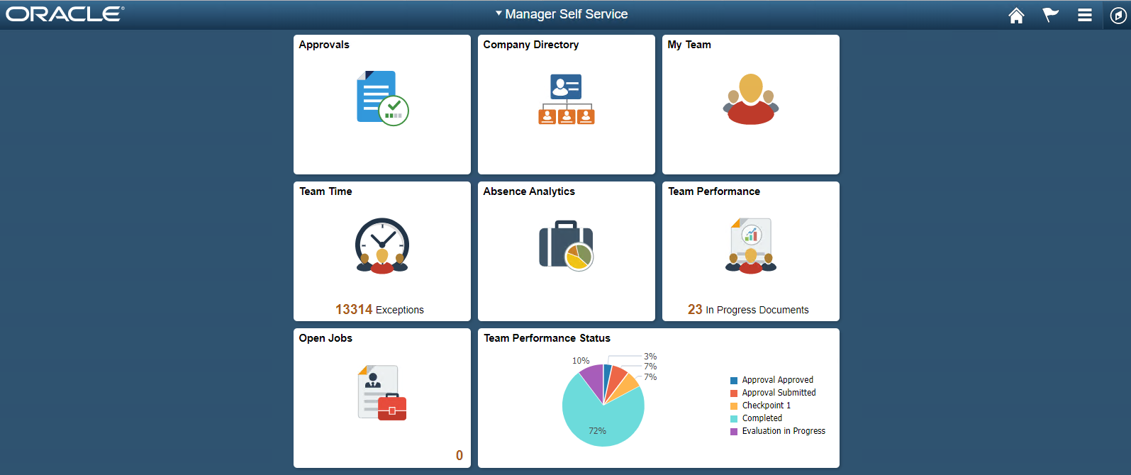

**Step 2:** In the PeopleSoft application, create *OAMPSFT* as a new user profile and associate a low security role such as PeopleSoft User.

Navigate to Peopletools >> Security >> User Profiles >> User Profiles to create a new user profile, for example: OAMPSFT and Add Peoplesoft User.

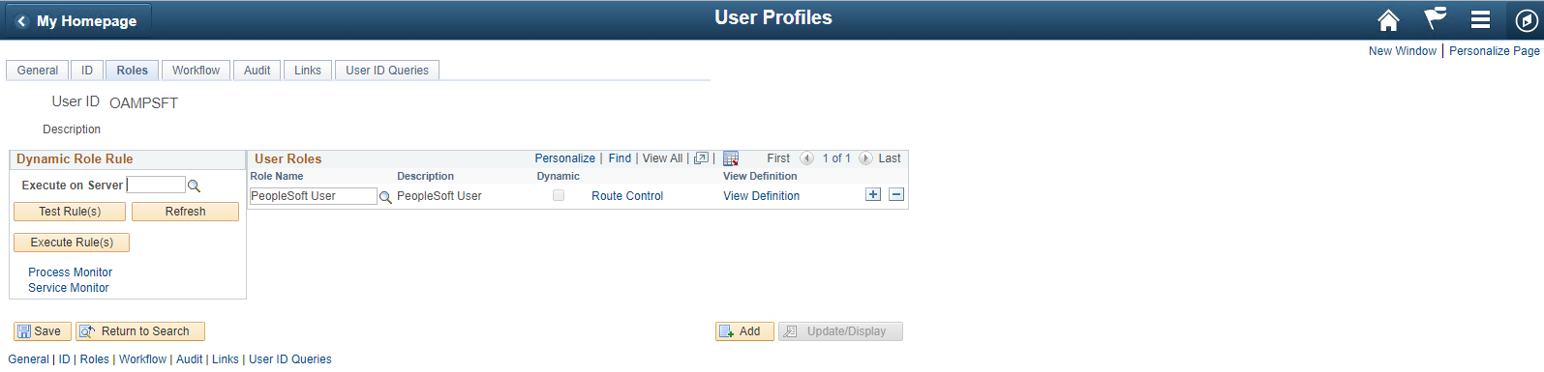

**Step 3:** Access the web profile and enter *OAMPSFT* as the public access user ID.

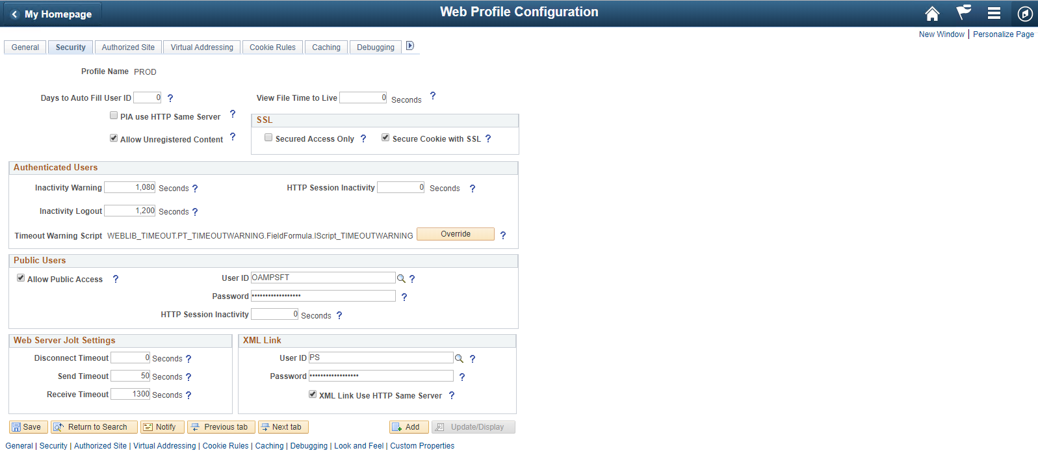

**Step 4:** From the PeopleTools Application Designer, open the FUNCLIB_LDAP record.

**Step 5:** Update the user Header with PS_SSO_UID for OAMSSO_AUTHENTICATION function.

In the getWWWAuthConfig() function, replace the value that is assigned to the &defaultUserId with the OAMPSFT that we defined in the Web profile. Save the record definition.

# **Step 6:** Access the Signon PeopleCode page (PeopleTools, Security, Security Objects, Signon PeopleCode) and enable the OAMSSO_AUTHENTICATION function—the Signon PeopleCode for Oracle Access Manager single signon.

# Part 6. Setting up F5 Big-IP APM to populate “PS_SSO_UID” HTTP Header with the PeopleSoft User ID

#### **Configuring Per-Request Policy**

Navigate to Access > Profile/Policies > Per-Request Policies, click **Create**, complete the following information and click **Finished**.

* Name: PeopleSoftSSO
* Profile Type: All
* Languages: English

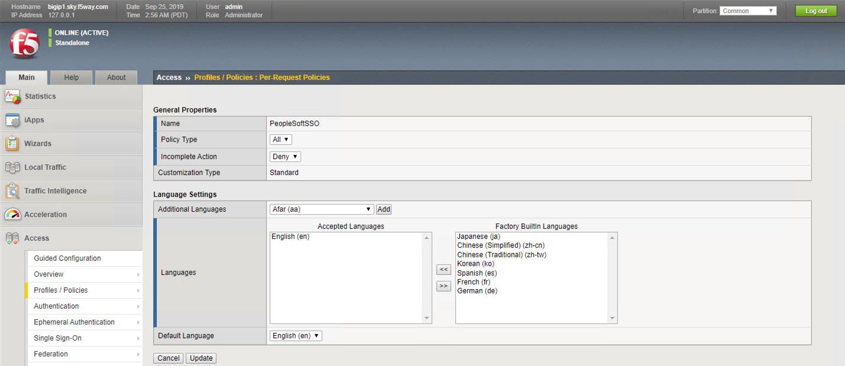

Click Edit Per-Request Policy “PeopleSoftSSO”

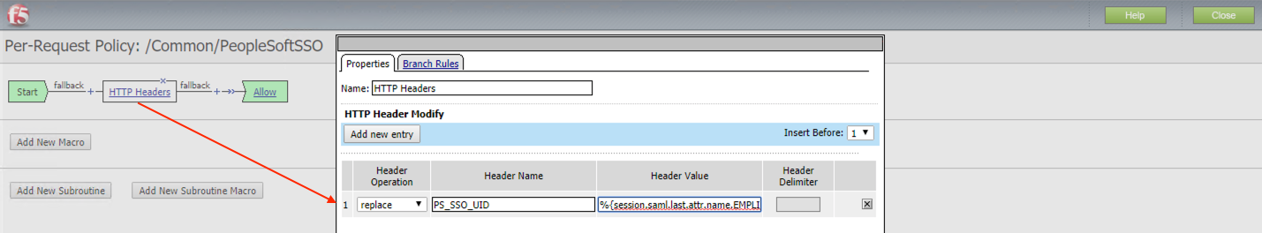

Header Name: PS_SSO_UID

Header Value: %{session.saml.last.attr.name.EMPLID}

#### **Assign Per-Request Policy to the Virtual Server**

Navigate to Loca**l Traffic > Virtual Servers > Virtual Server List > PeopleSoftApp**

Specify “PeopleSoftSSO” as Per-Request Policy

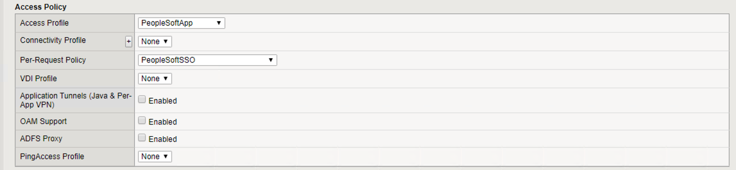

# Appendix

## SAML – F5 BIG-IP Variable mappings

